**EU MILK : The Price Of Freedom**

**How the EU dairy industry faired after the abolition of the milk quota**

On the first of April 2015, EU abolished the Milk Quota that had been in place for 30 years, since 1984.

The reason why Milk Quota were implemented for every member state of the EU was to manage the yearly recurring misbalances between Supply & Demand.

The milk quota system has been successful in terms of reducing milk production:

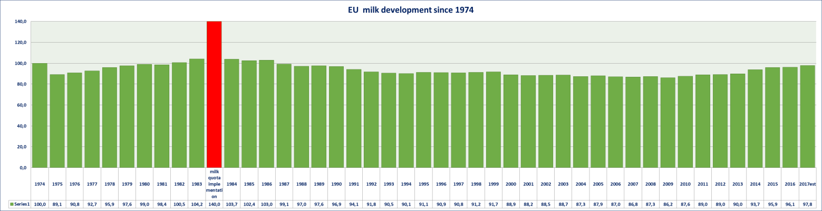

Since its implementation through to 2009, milk production was reduced by 20%, about 27 billion kgs. It wasn’t until 1993 that bigger steps were made. From 1993 through to 2010 milk production has been relatively stable. From 2010 till today however, milk production has gone up by 11,6%.

The milk quota tool has been effective in decreasing both milk production and intervention stocks. Looking at the below table, one *could* say that in 2005 EU had reached a balance. In successive years, we see intervention stocks go down with no new PI purchases until 2009. The 2009 PI purchases, however, had less to do with a structural misbalance between Supply & Demand rather than with the Financial/Banking Crisis that hit the world in 2008 which reduced demand temporarily. Production for SMP shot up by 17% in 2009 while the year had already started with a stock level in private hands of 651.000mt, a stock level we haven’t seen since.

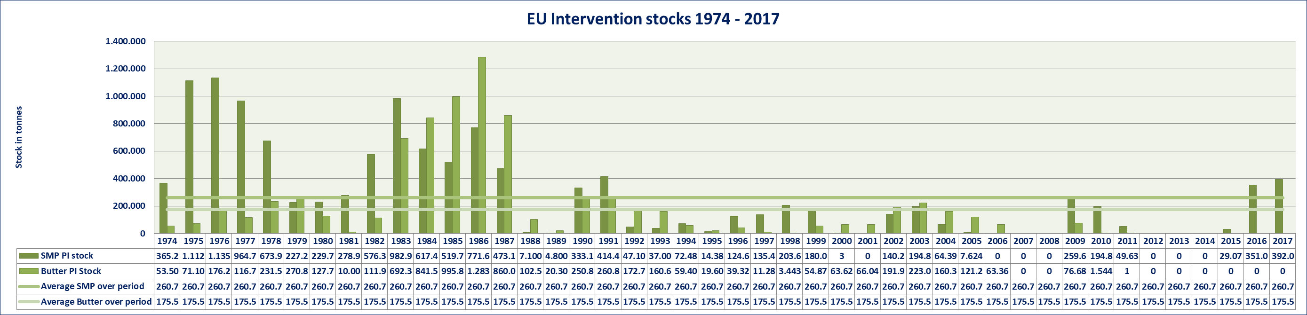

During the Milk Quota period, there have been 8 years where SMP intervention stocks were nonexistent. Most notably during the period from 2012- 2014. If we compare with table 1, we see that along with the abolition of Milk Quota in 2015, milk production jumps and PI stocks accumulate.

In the years before and after the Milk Quota years, there has not been a single year in which there were no Public Intervention stocks of SMP.

Unless there is strong management of milk production or rather, its growth, the above tables suggest that post the Milk Quota years, more often than not there will be PI stocks of SMP.

Butter is very different. During the Milk Quota period there have been six years in which there were no PI stocks. More often than with SMP there have been interventions stocks. The Butter stocks however have disappeared since 2011. The most important reason is that demand growth offset production growth and in recent years even outstripped production growth.

The current, historically low EU stocks underpin this.

The problem is, with the production of Butter, there is a significant stream of Skimmed Milk attached for which there are only so many options to process into commodities, ingredients or finished product.

In absence of viable and volume wise significant alternative products, other than SMP, to use the Skimmed Milk in, the conclusion is that as long as Butter and Cream production go up to meet with the increased demand for it, there will be a structural surplus of SMP. As we wrote in our recent Butter report, Butterfat consumption has increased and is unlikely to decrease any time soon.

The abolition of the Milk Quota has opened the doors for further milk production growth but the catch is that only some components of the milk have enough offtake to render growth sustainable. Butter is doing fine while SMP is all but. This makes it difficult to address the issue at its core. Obviously, incremental milk is required to meet demand for Butterfat but is superfluous in terms of Protein.

Besides the issues the Dairy Industry has in getting to terms with the misbalance in demand for Fat vs Protein, there appears to be another issue that is likely to ensure that rather than continuing to produce classic Butter for which more milk is required, they may have to look for alternatives to stretch Butterfat availability. One could think of lower Fat content in Butter or retaining the same Fat content of which part is vegetable oil.

An early example of stretching fat availability can be seen in the development of Fat Filled Milk Powder since the late nineties.

The main problem is that incremental and unmanaged milk production has cost the EU Dairy industry 13,5 million Euro in lost revenue every day from 1st May 2015 upto 28th February 2018:

If we look at average prices before and after the abolition of the Milk quota, this looks as follows:

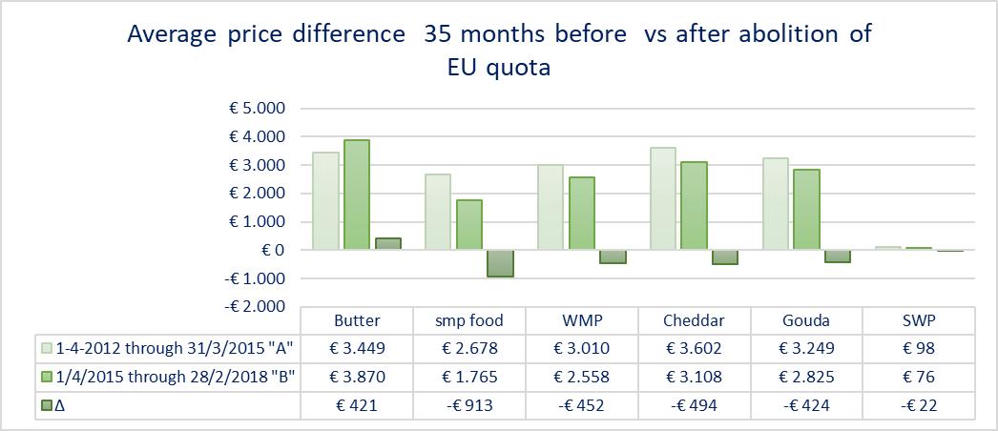

Even though Butter prices actually increased, all other prices went down, generating an overall lower stream return.

With regards to SMP & Butter the stream return in the mentioned period before the abolition of the Milk Quota was € 37/100 kgs. The stream return sank to € 31,60/100 kgs of Milk in the period afterwards. That is 15% lower.

If we look at annual production of the EU for the above products, the losses in sales revenues are significant:

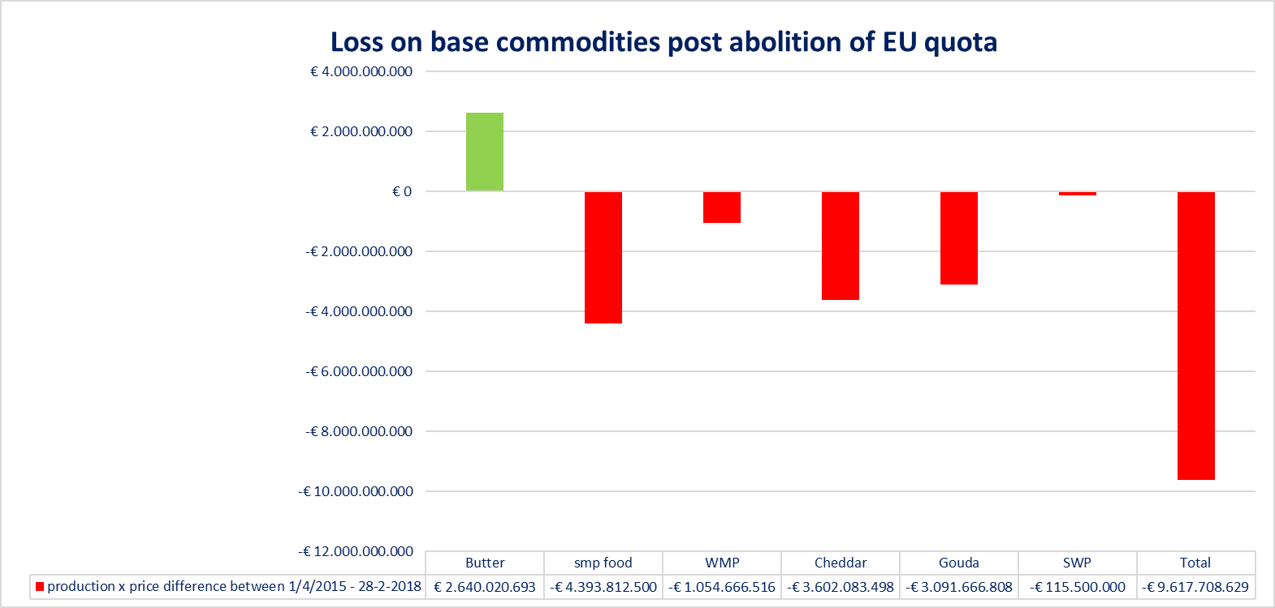

The total loss on the above products has been € 9,62 billion to the processors. The above products cover about 60 to 65% of total EU milk. We can rest assured that for the products produced from the balance of the milk, similar losses have been felt so that a more realistic estimate would be an annual loss in revenue closer to € 13,5 billion Euro. That is € 13,3 million each and every day of the year.

That as such doesn’t mean much in terms of how and if it affected the margins of processors, after all, farm gate prices declined too. That is an interesting one. If we look at average EU farm gate prices in the 35 months before and the 35 months after the abolition of the milk quota, it becomes clear that farmers saw their income decline by more than the processors did:

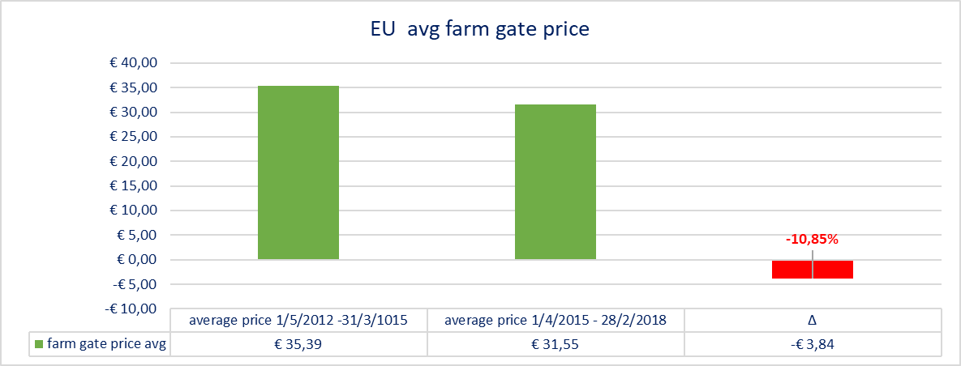

On the 153 billion kgs EU farmers produce every year, the loss of income in the 35 months post the abolition vs the 35 months before has been € 17,2 billion. With a dairy herd of 23,5 million head, that is a loss of income of € 732,-/ cow.

When we look at a number of milk producing countries, we come to the following loss of income on average farm level:



Besides that, the EU has laid out about € 700 million in buying up SMP. How much of that will be earned back through sales remains to be seen. Currently EU sells at € 1.050/mt with still 370.000mt in stock. On paper, there is already a foreseeable loss of € 239 million to the EU which is likely to increase over time. This is exclusive of losses already taken, finance costs and storage that amount to an approximate € 55 Million.

2017 has been a fairly good year for farm gate prices, with an average of € 34,21/100 kgs year to date October. This compares to € 28,43/100 kgs in 2016.

Currently, there is milk in abundance with still accelerating production increases fueled by high farm gate prices. Increasing production and as a result of that, lower finished product prices, will inevitably see farm gate prices go down so that extra revenue made in 2017 by dairy farmers will ( at least partially) evaporate in 2018 and beyond.

If we look at the cost of the abolition of the milk quota:

* To the Dairy industry from 1st April 2015 through to 31st December 2017 in lost revenue: € 14.769.000.000,-
* To the Dairy farmers from 1st April 2015 through to 31st December 2017 in lost income : € 17.212.829.184,-
* A minimum of € 285.000.000,- to the EU

Given the evaporated revenue and farm income on top of actual costs incurred by the EU tax payer since the abolition of the EU Milk Quota, it would be fair to say that the freedom to produce as much milk as one could has come at a tremendous price.

The soft landing post the abolition the EU spoke of beforehand hasn’t really materialised, although the EU commission may say it could have been worse, had they not interfered and they would absolutely be right about that.

The legacy of EU’s interference with the market however, is that the stocks frustrate a recovery of the market as the nearly 3 billion kgs of Liquid Milk Equivalent in the form of SMP stock will continue to burden the market.

The EU commission has said it is going to dispose of the stocks as soon as possible, using all available possibilities. This will not happen this year anymore but we may count with it for next year.

Unless the goods are destroyed through use as bio mass, or given away as food aid, the disposal will inevitably have a strong impact on the market at large.

With the misbalance between demand for Butterfat and Protein, the issue at hand is not an easy one but a first step would be to implement workable tools to manage milk production growth.

The majority of the dairy industry was strongly in favour of losing the Milk Quota but they, especially the farmer contingent among them, may well wonder if the price of being regulated has not been a real bargain compared to the current freedom.

**Greenmark Dairy, Robert Schorsij**